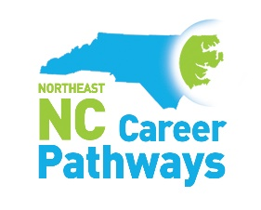
Agriscience/Biotechnology - Quarterly Meeting
Martin Community College
Building 1– Room 10
https://us06web.zoom.us/j/82665626022
June 11, 2024
10-11:30am

Welcome and Introductions Michael Williams, Chairman
NENC Career Pathways Partnership Updates Brandi Bragg, Workforce Connector
Agriscience/Biotechnology Pathway Brandi Bragg, Workforce Connector
SkillsUSA Activity – Professionalism
Partner Spotlight
NC Department of Commerce – Agricultural Employment Tyler Bennett, Consultant

Networking Break
Partner Highlight & Success Stories
Martin Community College – Agriculture Program Dr. Tabitha Miller, President
Martin Community College – Equine Program Tammie Thurston, Director
Student Success Story

Join us for an optional tour of the Horse Barn after the meeting.
Local Places to Eat

Georgia Deans – 1940 US-17 BUS, Williamston, NC 27892
Shamrock (Buffet) - 101 West Blvd, Williamston, NC 27892
Hitching Post (Buffet) - 1981 US-17 BUS, Williamston, NC 27892
Shaw’s BBQ - 202 West Blvd, Williamston, NC 27892

