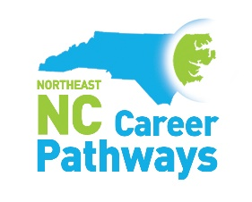
Health Care - Quarterly Meeting
Eastern AHEC – Greenville, NC
November 29, 2023
10-11:30am

Welcome and Introductions Michael Williams, Chairman
NENC Career Pathways Partnership Updates Brandi Bragg, Workforce Connector
Health Care Pathway Brandi Bragg, Workforce Connector
SkillsUSA Activity – Adaptability/Flexibility
Employer Spotlight
ECU Health Maynard Children’s Hospital Erika Greene, Pediatric Trauma Program Mgr.

Networking Break
Partner Spotlight
NC East Alliance Bruce Middleton, Executive Director STEMEast
Highlight
Eastern AHEC Dr. Lorrie Basnight, Executive Director
Blair Savoca Forde, Director of Student Services

Sharing Stories of Success

Join us for an optional tour of the ECU Health Pediatric Trauma Unit Simulator in the parking lot after the meeting.
Save the Date

Wednesday, January 10, 2024 – Career Pathways Training – Roanoke-Chowan Community College
Wednesday, March 13, 2024 – Quarterly Meeting – Business Support Services – Beaufort County Community College
Tuesday, June 11, 2024 – Quarterly Meeting – Agriscience/Biotechnology – Martin Community College

