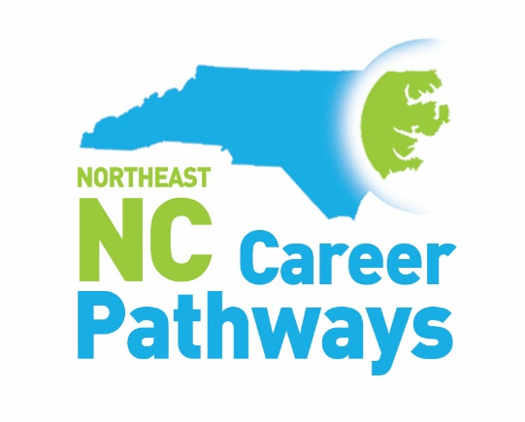
Career Pathways 8th Annual Guidance Retreat
Career Pathway Experience
Monday, September 18, 2023
Goess Student Center at Pitt Community College
9 am-3 pm

Registration (8:30 am until 9 am)
Welcome & Overview
Icebreaker
Career Pathways Vocabulary Exercise
Networking Break
Persona Workshop
Identifying Barriers
Morning Debrief/Resource Discussion

11:45-12:45 – Lunch & Resource Fair 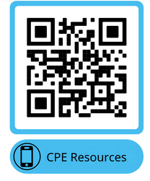

Team building
Concept Overview
Build your career pathways plan
Debrief

Please complete the evaluation using this QR code:

