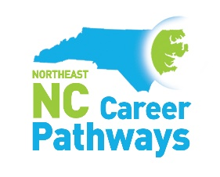
Agriscience/Biotechnology - Quarterly Meeting
Pitt Community College – Walter & Marie Williams Building
June 14, 2023
10-11:30am

Welcome and Introductions Michael Williams, Chairman
NENC Career Pathways Partnership Updates Brandi Bragg, Workforce Connector
Agriscience/Biotechnology Pathway Brandi Bragg, Workforce Connector
Partner Spotlights
Telamon Tashia Harrison, Business & Industry Liaison
NC Biotechnology Center Mark Phillips, Director- Eastern Regional

Networking Break

Employer Perspective – Catalent Micah Geiger, Human Resources Director
Highlight – Pitt CC Biotechnology Christy Weeks, Biotechnology Department Chair
Sharing Stories of Success Trisha Riley, Microbiologist I @ Catalent
Join us for an optional tour of the Biotechnology labs beginning after the meeting.
Save the Date

Thursday, September 14, 2023 – Quarterly Meeting - Advanced Manufacturing, Nash Community College
Monday, September 18, 2023 - Annual Guidance Retreat, Pitt Community College
Tuesday, October 17, 2023 – Career Pathways Training - College of the Albemarle – Dare Campus
Wednesday, November 29, 2023 – Quarterly Meeting – Health Care – Eastern AHEC (Greenville)
Wednesday, January 10, 2024 – Career Pathways Training – Roanoke-Chowan Community College
Wednesday, March 13, 2024 – Quarterly Meeting – Business Support Services – Beaufort County Community College
Tuesday, June 11, 2024 – Quarterly Meeting – Agriscience/Biotechnology – Martin Community College

