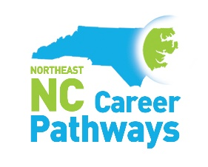
Advanced Manufacturing - Quarterly Meeting
Halifax Community College
November 17, 2022
10-11:30am

Welcome Walter Dorsey, Chairman
NENC Career Pathways Partnership Updates Brandi Bragg, CP Facilitator
Partner Spotlights
ECSU NASA Grant Dr. Akbar Eslami/Dr. Kuldeep Rawat
Rivers East Academy Todd Borghesani, Project Manager
Center For Energy Education Whitney Sessoms, Workforce & Education Manager
ApprenticeshipNC Scott Panagrosso, Apprenticeship Coordinator
Sara Lee Frozen Bakery Charles Gilmore, HR Training Generalist
“In Your Backyard” Duna Long, Turning Point WDB

Networking Break
Employer Perspective – WestRock Lamont Fenner, Sr. Reliability Engineer
Highlight – RampEast/Solar Energy Dr. Jeffrey Fields, VP Academic Affairs
Story of Success

Join us for an optional tour of the Advanced Manufacturing building beginning at 11:30am

Lunch Options Nearby:
Cafe 300 - located in the 300 Building of Halifax Community College's campus
The Mill Coffee & Eatery - 1020 Roanoke Ave, Roanoke Rapids, NC 27870
Ralph’s BBQ – 1400 Julian R Allsbrook Hwy, Weldon, NC 27890
Don Juan Mexican Restaurante -- 270 Premier Blvd, Roanoke Rapids, NC 27870

