What Credit Card is Right for Me?
Credit Score
What is a credit score?

https://www.freecreditscore.com/
What are some of the elements my credit is based on?
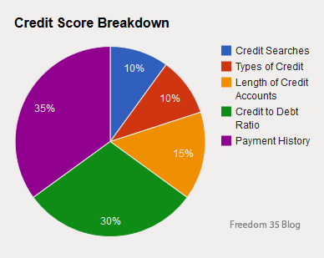
Is it safe to put my social security number in a website?
*REMEMBER this information for future log ins. Record below for future access.
__________________________(user name)(email)
__________________________(password)

If there is information you would like to dispute, how would you do so? (See Supports/Disputes Guide at the bottom of the page)
___________________________________________________________________________________

Comparing Cards
Nerdwallet: 11 Excellent Credit Cards for 2021 http://bit.ly/3cbfzBO
Unfamiliar terms
What card seems right for me?
Participant Feedback Link
http://survey.constantcontact.com/survey/a07egzubx6tk88vps5l/start

