Northeastern North Carolina Career Pathways Partnership
2020 Fall Partners Meeting
November 12, 2020 10am-11:30am

Welcome Walter Dorsey
Chair

Partnership Updates Brandi Bragg
Career Pathways Facilitator

MyFutureNC Melissa Caperton
Director of Regional Impact
Dr. Jeni Corn
Director of Strategic Initiatives

Success Story Erica Banks
Youth Career Advisor, NWDB Lora Aples
NEXTGEN Program Manager
ApprenticeshipNC/NCPAYA Dr. Elizabeth Standafer
Youth Apprenticeship Manager

Partner Updates Group

Thank you for being great partners!

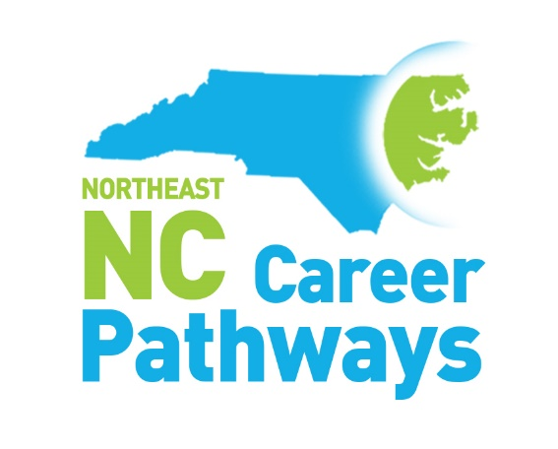
www.nencpathways.org

