Links
Traitify (for NENC area): http://nencpathways.traitify.com
NCCareers: www.nccareers.org
Transferable Skills article: https://www.thebalancecareers.com/transferable-skills-list-525490
Career OneStop Skills Matcher: https://www.careeronestop.org/toolkit/Skills/skills-matcher-questions.aspx

NENC Career Ladders: www.nencpathways.org

LMI Data Dashboard: www.ncworks.gov

GADJ: http://riverseastwdb.org/staff-resources/guidance-direction-for-job-seekers/

Goodwill Community Foundation “Learn Free” video & training: www.gcflearnfree.org

Essential Skills article: https://www.cnbc.com/2019/11/21/10-top-soft-skills-to-master-for-2020-if-you-want-a-raise-promotion-or-new-job.html

Your Information
Traitify Blend: _________________________/__________________________
NCCareers Interest Categories (top 3):
________________________, ____________________________, ________________________
Reality Check “Minimum Household Income”:
$_______________________________
Skill Matcher (top 3 career matches):
________________________, ____________________________, _______________________

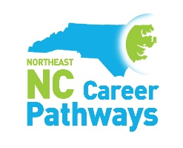
www.nencpathways.org

