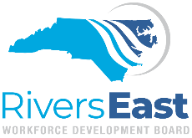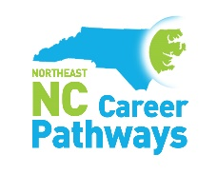

June 5, 2020
Dear Partner,
Nearly two years ago, a small group of like-minded local agency representatives recognized the need to increase and improve networking in Pitt County. We were already collaborating in a monthly WIOA partnership meeting when we recognized how little we actually knew about the agencies operating around the county. Meeting participants often exclaimed after a presentation or discussion that they had no idea what the other agencies were able to do, or what they were accomplishing in our community. Opportunities for collaboration were apparent and left us seeking more.
Last August, we convened a group of more than 50 representatives from at least 23 agencies in Pitt County for the inaugural agency resource event. “Networking Redesigned” was developed to encourage collaboration and resource sharing within the local community. The purposes of this event were to promote interaction and partnerships within the Pitt County Community, help reduce duplicated efforts among our partners, increase awareness of available resources and services for our clientele, and finally, develop a model that other regions and communities can use to promote these same goals.
Feedback from the inaugural event was amazing and calls for an annual event have continued. We are currently in the process of planning the next event for July 16, 2020. This year, we hope to be able to include representatives from even more agencies within Pitt County plus include partners from Beaufort, Bertie, Hertford and Martin Counties. We will be conducting this years’ event online, utilizing the Virtual Career Fair platform through Rivers East Workforce Development Board.
Last year we were lucky to have sponsors from Rivers East Workforce Development Board, Pitt Community College Foundation, Pitt County DSS and NENC Career Pathways to provide food and supplies. This year, we would like to ask your organization to contribute to this effort. Because of the virtual event, we are requesting donations of prizes to be awarded for participants. We would love to highlight your organization in all promotional materials and throughout the event and to have your representatives participate if possible. Please contact any of us to talk about how you can become a sponsor for this interactive event.
We look forward to greater opportunities for collaboration throughout our community. Will you join us?
Sincerely,
Networking ReDesigned
Laurie Weston <lweston@email.pittcc.edu>
Dee Hill <deidire.hill@pittcountync.gov>
Jamie Heath <jheath@mideastcom.org>
Brandi Bragg <brandi.bragg@nencpathways.org>

