2018-2019
Brandi Bragg
Career Pathways Facilitator
Spring 2020
Health Care Metrics
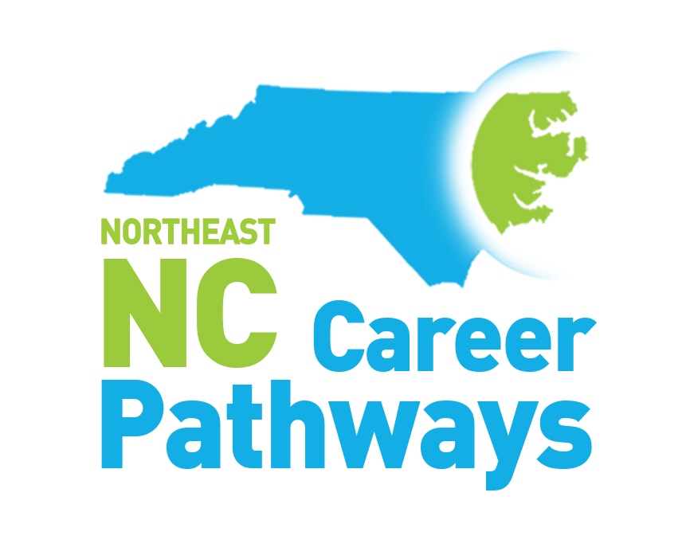
Secondary School, Community College and Workforce Development Board Measures Summary
Northeastern NC Career Pathways
Health Care Pathway
Community College Progress Measures
Work-based Learning, Community College Completers, Employer Engagement

Progress Measure | 2014-2015 | 2015-2016 | 2016-2017 | 2017-2018 | 2018-2019
Number of employers providing Health Care related work-based learning experiences to students | 249 | 491 | 222 | 225 | 83
Number of students who experienced a Health Care related work-based learning opportunity | 2318 | 4406 | 3340 | 3589 | 1222
Number of Health Care programs in which students earned certificates, diplomas, and/or associate science degrees | 31 | 43 | 46 | 45 | 86
Number of students who earned Health Care certificates, diplomas, and/or associate science degrees | 2324 | 4027 | 3347 | 2745 | 2096

Health Care Programs:
Activity Director
AEMT
Advanced Medical Coding
Basic Medical Office
Computed Tomography
Dental Assisting
Dental Office Administration
Dental Hygenist
Dietary Management
Emergency Medical Sciences
Emer. Med. Tech. - Intermediate (EMT 1)
Emer. Med. Tech. - Paramedic
Emergency Medical Technician (EMT Basic)
Health Fitness Science
Health Information Technology - Coding
Healthcare Business Informatics
Healthcare Database Admin & Support
Healthcare Infrastructure Support
Healthcare IT Foundations
Healthcare Management Technology
Human Services Technology
Magnetic Resonance Imaging
Medical Assisting
Medical Auditor
Medical Billing and Coding
Medical Information Technology
Medical Insurance Coding
Medical Lab Technician
Medical Office Administration
MOA: Medical Auditing
MOA: Patient Services Specialist
Medical Office Receptionist
Medical Office Specialist
Medical Responder
Medication Aide (DHSR Registry)
Nuclear Medicine
Nurse Aide I (DHSR registry)
Nurse Aide II (NCBON registry)
Nursing
Opthalmic Medical Personnel
Patient Representative Certificate
Pharmacy Technician
Phlebotomy (NHA)
Physical Therapist Assistant
Practical Nursing (LPN)
Radiography
Respiratory Therapy
Surgical Technology

Northeastern North Carolina Career Pathways
Health Care Pathway
Workforce Development Boards

Progress Measures | Year Ending  6/30/15 | Year Ending  6/30/16 | Year Ending  6/30/17 | Year Ending  6/30/18 | Year Ending 6/30/19
Adult Measures
The number of adult clients enrolled in Health Care Pathway at a community college | 539 | 549 | 671 | 432 | 362
The number of adult clients who earned a Health Care credential | 303 | 406 | 500 | 269 | 162
The number of adult clients employed in a Health Care career | 221 | 328 | 387 | 246 | 108
Youth Measures
The number of youth clients enrolled in a high school diploma program | 197 | 193 | 173 | 186 | 119
The number of youth clients enrolled in a high school equivalency program | 134 | 201 | 161 | 152 | 63
The number of youth clients enrolled in a Health Care Pathway at a community college | 34 | 54 | 91 | 71 | 39
The number of youth clients enrolled in pathways other than Health Care | 73 | 80 | 59 | 57 | 32
The number of youth clients employed in a Health Care career | N/A | N/A | N/A | N/A | 4

North Carolina Northeast Career Pathways
Health Care Pathways
Secondary School Measures

Progress Measure | 2013-2014 | 2014-2015 | 2015-2016 | 2016-2017 | 2017-2018 | 2018-2019
Concentrator and Industry Credentials Measures
Number of students who complete the high school requirements to be recognized as a health care pathway concentrator | 460 | 472 | 442 | 702 | 473 | 465
Number of Students who achieve health care related credentials | 716 | 1288 | 1393 | 898 | 275 | 1205
Career Readiness Certificates (CRCs) | 2705 | 2887 | 2383 | 2843 | 2670 | 1835
Work-based Learning and Employer Engagement Measures
Number of employers providing health care related work-based learning opportunities | 83 | 164 | 152 | 188 | 166 | 82
Number of students provided an health care related work-based learning opportunity | 535 | 1534 | 1417 | 1970 | 1814 | 1105
Number of employers engaged in activities related to health care instruction other than work-based learning | 142 | 168 | 155 | 252 | 216 | N/A
Activities that support Pathway Completion Measures
No./% of LEAs offering 7 or more career guidance activities in which 75% or more of a grade level participated | 6/30% | 8/38% | 8/44% | 2/13% | 7/41% | N/A
Number of NC Career and College Promise courses completed in a health care pathway | 48 | 22 | 78 | 866 | 719 | 421
Number of CCP college transfer courses completed | 1134 | 1765 | 2845 | 6526 | 6223 | N/A

College and Career Exposure Activities offered (7th through 12th)

- Community/Guest Speakers
- Ready, Set, App – Guest Speaker (Tech)
- Career Fairs
- CTE Career Collaboration
- CTE Middle School X-Factor
- Graduates Ready & Digitally Driven (GRADD)
- Job Shadowing (in person and virtual)
- STEM Fair
- Open House
- Career Conversations
- Career Cluster & Pathway Lessons
- Librarian Job Skills Exploratory Activities
- CFNC transition
- Learning Style Inventories
- EverFi “Key to my future” activity
- College Tours
- Grow Local initiative
- Ag Fest/Ag Expo
- IMatter Rally
- FAFSA
- Career & College Readiness presentations
- Workkeys bootcamps
- Senior Interview Days
- College Application Week

