2018-2019
Brandi Bragg
Career Pathways Facilitator
Spring 2020
Business Support Services Metrics
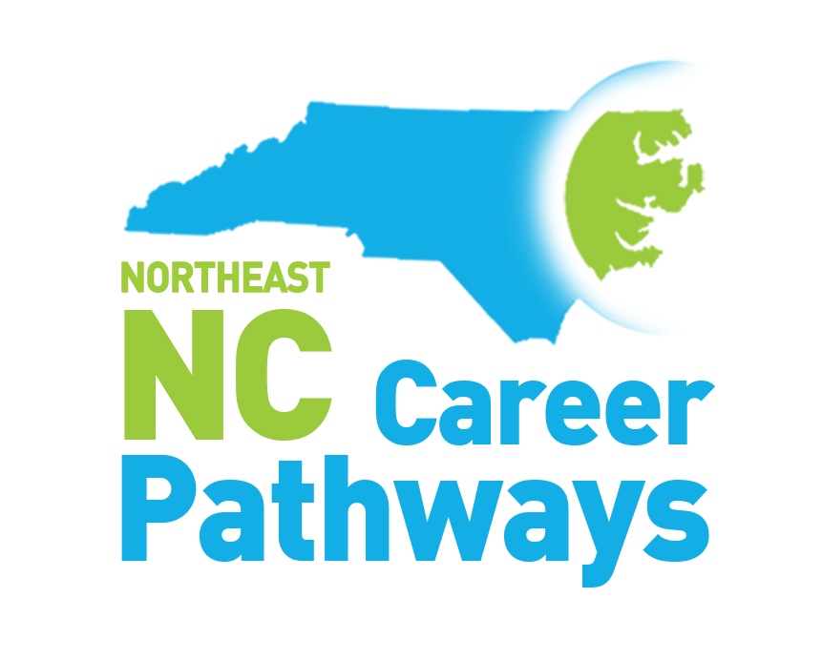
Secondary School, Community College and Workforce Development Board Measures Summary
Northeastern NC Career Pathways
Business Support Services Pathway
Community College Progress Measures
Work-based Learning, Community College Completers, Employer Engagement

Progress Measure | 2016-2017 | 2017-2018 | 2018-2019 | 2019-2020
Number of employers providing Business Support Services related work-based learning experiences to students | 46 | 81 | 32
Number of students who experienced a Business Support Services related work-based learning opportunity | 79 | 106 | 50
Number of Business Support Services programs in which students earned certificates, diplomas and/or associate science degrees | 52 | 33 | 19
Number of students who earned Business Support Services certificates, diplomas, and/or associate science degrees | 792 | 1450 | 165

Business Support Services Programs:
Accounting
Advertising and Graphic Design
Budgeting/Finance (certificate)
Business Administration
Business Startup - Entrepreneurship Mindsets
CISCO CCNA PREP
Computer Programming and Development
Computer Upgrade and Repair Technician
Distribution Management
Entrepreneurship
Financial Services
Global Business Management
Human Resource Management
Information Technology
IT Cyber Security
IT Information Systems
IT Project Management
IT System Administrations & Support
IT Technical Support

Legal Office
Logistics Analysis
Management Supervision
Marketing
Network Management
Office Administration
Office Administration/Legal
Office Finance
Paralegal Technology
Professional Crafts - Entrepreneurship
Security Systems Concept
Simulation and Game Development
Small Business Management
Small Business Startup
Supply Chain Management
System Security
Web Design and Administration
Workplace IT Professional

Northeastern North Carolina Career Pathways
Business Support Services Pathway
Workforce Development Boards

Progress Measures | Year Ending  6/30/17 | Year Ending  6/30/18 | Year Ending  6/30/19 | Year Ending  6/30/20
Adult Measures
The number of adult clients enrolled in Business Support Services at a community college | 23 | 36 | 190
The number of adult clients who earned a Business Support Services credential | 25 | 25 | 108
The number of adult clients employed in a Business Support Services career | 21 | 32 | 66
Youth Measures
The number of youth clients enrolled in a high school diploma program | 173 | 186 | 119
The number of youth clients enrolled in a high school equivalency program | 161 | 152 | 63
The number of youth clients enrolled in a Business Support Services at a community college | 8 | 8 | 9
The number of youth clients enrolled in pathways other than Business Support Services | 142 | 120 | 62
The number of youth clients employed in a Business Support Services career | N/A | N/A | 4

North Carolina Northeast Career Pathways
Business Support Services Pathways
Secondary School Measures

Progress Measure | 2016-2017 | 2017-2018 | 2018-2019 | 2019-2020
Concentrator and Industry Credentials Measures
Number of students who complete the high school requirements to be recognized as a business support services pathway concentrator | 605* | 439~ | 645
Number of Students who achieve business support services related credentials | 5212 | 1492 | 895
Career Readiness Certificates (CRCs) | 2843 | 2670 | 1835
Work-based Learning and Employer Engagement Measures
Number of employers providing business support services related work-based learning opportunities | 99 | 141 | 131
Number of students provided a business support services related work-based learning opportunity | 435 | 579 | 1102
Number of employers engaged in activities related to business support services instruction other than work-based learning | 241 | 224 | N/A
Activities that support Pathway Completion Measures
No./% of LEAs offering 7 or more career guidance activities in which 75% or more of a grade level participated | 2/13% | 7/41% | N/A
Number of NC Career and College Promise courses completed in a business support services pathway | 1310 | 771 | 2904
Number of CCP college transfer courses completed | 6526 | 6223 | N/A
*BSS concentrators include Business Management, IT, Finance and Transportation
~added Marketing

College & Career Exposure Activities offered (7th through 12th)

- Community/Guest Speakers
- Ready, Set, App – Guest Speaker (Tech)
- Career Fairs
- CTE Career Collaboration
- CTE Middle School X-Factor
- Graduates Ready & Digitally Driven (GRADD)
- Job Shadowing (in person and virtual)
- STEM Fair
- Open House
- Career Conversations
- Career Cluster & Pathway Lessons
- Librarian Job Skills Exploratory Activities
- CFNC transition
- Learning Style Inventories
- EverFi “Key to my future” activity
- College Tours
- Grow Local initiative
- Ag Fest/Ag Expo
- IMatter Rally
- FAFSA
- Career & College Readiness presentations
- Workkeys bootcamps
- Senior Interview Days
- College Application Week

