2018-2019
Brandi Bragg
Career Pathways Facilitator
Spring 2020
Agriscience/Biotechnology Metrics
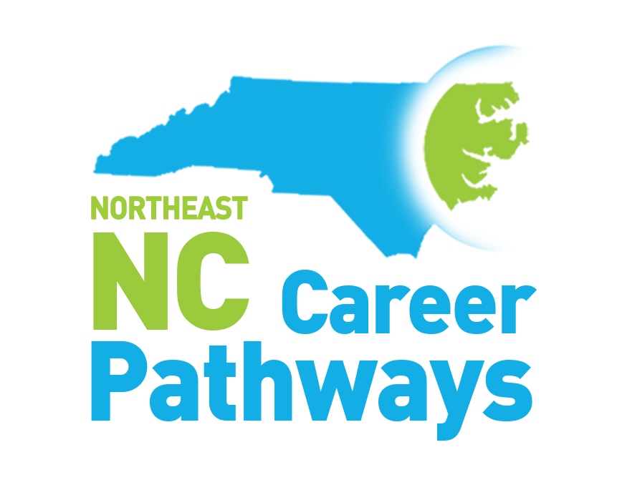
Secondary School, Community College and Workforce Development Board Measures Summary
Northeastern NC Career Pathways
Agriscience/Biotechnology Pathway
Community College Progress Measures
Work-based Learning, Community College Completers, Employer Engagement

Progress Measure | 2014-2015 | 2015-2016 | 2016-2017 | 2017-2018 | 2018-2019
Number of employers providing Agriscience/Biotechnology related work-based learning experiences to students | 18 | 27 | 23 | 16 | 12
Number of students who experienced an Agriscience/Biotechnology related work-based learning opportunity | 24 | 69 | 42 | 17 | 65
Number of Agriscience/Biotechnology programs in which students earned certificates, diplomas and/or associate science degrees | 8 | 11 | 16 | 8 | 19
Number of students who earned Agriscience/Biotechnology certificates, diplomas, and/or associate science degrees | 211 | 332 | 230 | 227 | 165

Agriscience/Biotechnology Programs:
Agribusiness Technology
Biotechnology
Biowork Process Technician
Culinary Arts
Elementary Culinary
Intermediate Culinary
Foodservice Technology
ServSafe Certification
Restaurant Management
Catering Management
Equine Business Technology
Equine Training Technology
Horticulture Technology
Veterinary Assistant
Agriculture Entreprenuership
Event Planning (certificate)
Essential Culinary Skills (certificate)
Baking (certificate)
Advanced Catering for Entertaining (certificate)

Northeastern North Carolina Career Pathways
Agriscience/Biotechnology Pathway
Workforce Development Boards

Progress Measures | Year Ending  6/30/15 | Year Ending  6/30/16 | Year Ending  6/30/17 | Year Ending  6/30/18 | Year Ending 6/30/19
Adult Measures
The number of adult clients enrolled in Agriscience/Biotechnology Pathway at a community college | 7 | 3 | 2 | 3 | 2
The number of adult clients who earned an Agriscience/Biotechnology credential | 6 | 1 | 2 | 2 | 2
The number of adult clients employed in an Agriscience/Biotechnology career | 4 | 1 | 0 | 1 | 0
Youth Measures
The number of youth clients enrolled in a high school diploma program | 197 | 193 | 173 | 186 | 119
The number of youth clients enrolled in a high school equivalency program | 134 | 201 | 161 | 152 | 63
The number of youth clients enrolled in an Agriscience/Biotechnology Pathway at a community college | 1 | 18 | 0 | 1 | 3
The number of youth clients enrolled in pathways other than Agriscience/Biotechnology | 104 | 126 | 104 | 132 | 68
The number of youth clients employed in an Agriscience/Biotechnology career | N/A | N/A | N/A | N/A | 0

North Carolina Northeast Career Pathways
Agriscience/Biotechnology Pathways
Secondary School Measures

Progress Measure | 2014-2015 | 2015-2016 | 2016-2017 | 2017-2018 | 2018-2019
Concentrator and Industry Credentials Measures
Number of students who complete the high school requirements to be recognized as an agriscience/biotechnology pathway concentrator | 617 | 607 | 726 | 661 | 460
Number of Students who achieve agriscience/biotechnology related credentials | 267 | 184 | 717 | 125 | 296
Career Readiness Certificates (CRCs) | 2887 | 2383 | 2843 | 2670 | 1835
Work-based Learning and Employer Engagement Measures
Number of employers providing agriscience/biotechnology related work-based learning opportunities | 210 | 138 | 158 | 184 | 125
Number of students provided an agriscience/biotechnology related work-based learning opportunity | 1689 | 675 | 1276 | 1527 | 959
Number of employers engaged in activities related to agriscience/biotechnology instruction other than work-based learning | 246 | 191 | 225 | 294 | N/A
Activities that support Pathway Completion Measures
No./% of LEAs offering 7 or more career guidance activities in which 75% or more of a grade level participated | 8/38% | 8/44% | 2/13% | 7/41% | N/A
Number of NC Career and College Promise courses completed in an agriscience/biotechology pathway | 18 | 3 | 170 | 6 | 296
Number of CCP college transfer courses completed | 1765 | 2845 | 6526 | 6223 | N/A

College & Career Exposure Activities offered (7th through 12th)

- Community/Guest Speakers
- Ready, Set, App – Guest Speaker (Tech)
- Career Fairs
- CTE Career Collaboration
- CTE Middle School X-Factor
- Graduates Ready & Digitally Driven (GRADD)
- Job Shadowing (in person and virtual)
- STEM Fair
- Open House
- Career Conversations
- Career Cluster & Pathway Lessons
- Librarian Job Skills Exploratory Activities
- CFNC transition
- Learning Style Inventories
- EverFi “Key to my future” activity
- College Tours
- Grow Local initiative
- Ag Fest/Ag Expo
- IMatter Rally
- FAFSA
- Career & College Readiness presentations
- Workkeys bootcamps
- Senior Interview Days
- College Application Week

