2018-2019
Brandi Bragg
Career Pathways Facilitator
Spring 2020
Advanced Manufacturing Metrics
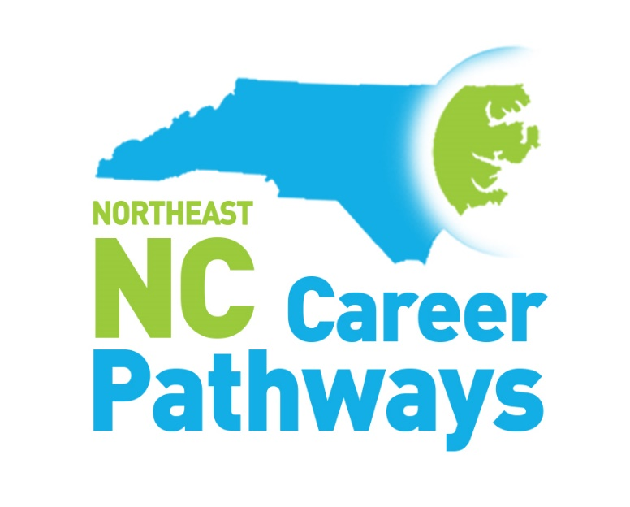
Secondary School, Community College and Workforce Development Board Measures Summary
Northeastern NC Career Pathways
Advanced Manufacturing Pathway
Community College Progress Measures
Work-based Learning, Community College Completers, Employer Engagement

Progress Measure | 2014-2015 | 2015-2016 | 2016-2017 | 2017-2018 | 2018-2019
Number of employers providing Advanced Manufacturing related work-based learning experiences to students | 16 | 19 | 20 | 29 | 14
Number of students who experienced an Advanced Manufacturing related work-based learning opportunity | 27 | 31 | 23 | 34 | 144
Number of Advanced Manufacturing programs in which students earned certificates, diplomas and/or associate science degrees | 19 | 19 | 45 | 43 | 41
Number of students who earned Advanced Manufacturing certificates, diplomas, and/or associate science degrees | 1055 | 975 | 2631 | 2944 | 824

Northeastern NC Career Pathways
Advanced Manufacturing Pathway
Community College Progress Measures
Advanced Manufacturing Programs

- Aviation Technology
- Computer Integrated Machining
- HVAC
- Welding Technology
- Computer Aided Drafting
- Electrical Engineering Technoloyg
- Electrical Systems Technology
- Electrical/Electronics Technology
- Air Conditioning
- Heat Pumps
- Industrial Systems Technology
- Commercial Refrigeration
- Fork Lift Training
- Mechanical Engineering Technician
- Basics of Tire Manufacturing

Northeastern North Carolina Career Pathways
Advanced Manufacturing Pathway
Workforce Development Boards

Progress Measures | Year Ending  6/30/15 | Year Ending  6/30/16 | Year Ending  6/30/17 | Year Ending  6/30/18 | Year Ending 6/30/19
Adult Measures
The number of adult clients enrolled in Advanced Manufacturing Pathway at a community college | 43 | 58 | 81 | 31 | 61
The number of adult clients who earned an Advanced Manufacturing credential | 18 | 33 | 48 | 18 | 12
The number of adult clients employed in an Advanced Manufacturing career | 10 | 28 | 39 | 17 | 7
Youth Measures
The number of youth clients enrolled in a high school diploma program | 184 | 193 | 173 | 186 | 119
The number of youth clients enrolled in a high school equivalency program | 120 | 201 | 161 | 152 | 63
The number of youth clients enrolled in an Advanced Manufacturing Pathway at a community college | 14 | 24 | 30 | 31 | 13
The number of youth clients enrolled in pathways other than Advanced Manufacturing | 90 | 120 | 120 | 97 | 58
The number of youth clients employed in an Advanced Manufacturing career | N/A | N/A | N/A | N/A | 9

North Carolina Northeast Career Pathways
Advanced Manufacturing Pathways
Secondary School Measures

Progress Measure | 2013-2014 | 2014-2015 | 2015-2016 | 2016-2017 | 2017-2018 | 2018-2019
Concentrator and Industry Credentials Measures
Number of students who complete the high school requirements to be recognized as an advanced manufacturing pathway concentrator* | 114 | 117 | 71 | 140 | 121 | 260
Number of Students who achieve advanced manufacturing related credentials | 77 | 475 | 405 | 1678 | 3345 | 4577
Career Readiness Certificates (CRCs) | 2705 | 2887 | 2383 | 2843 | 2670 | 1835
Work-based Learning and Employer Engagement Measures
Number of employers providing advanced manufacturing related work-based learning opportunities | N/A | 53 | 44 | 71 | 77 | 86
Number of students provided an advanced manufacturing related work-based learning opportunity | N/A | 36 | 651 | 728 | 837 | 1024
Number of employers engaged in activities related to advanced manufacturing instruction other than work-based learning | N/A | 61 | 53 | 106 | 127 | N/A
Activities that support Pathway Completion Measures
No./% of LEAs offering 7 or more career guidance activities in which 75% or more of a grade level participated | 6/29% | 8/38% | 8/44% | 2/13% | 7/41% | N/A
Number of NC Career and College Promise courses completed in an advanced manufacturing pathway | 92 | 70 | 273 | 481 | 676 | 435
Number of CCP college transfer courses completed | 1134 | 1765 | 2845 | 6526 | 6223 | N/A

*Includes students enrolled in Manufacturing and STEM clusters

College and Career Exposure Activities offered (7th through 12th)

- Community/Guest Speakers
- Ready, Set, App – Guest Speaker (Tech)
- Career Fairs
- CTE Career Collaboration
- CTE Middle School X-Factor
- Graduates Ready & Digitally Driven (GRADD)
- Job Shadowing (in person and virtual)
- STEM Fair
- Open House
- Career Conversations
- Career Cluster & Pathway Lessons
- Librarian Job Skills Exploratory Activities
- CFNC transition
- Learning Style Inventories
- EverFi “Key to my future” activity
- College Tours
- Grow Local initiative
- Ag Fest/Ag Expo
- IMatter Rally
- FAFSA
- Career & College Readiness presentations
- Workkeys bootcamps
- Senior Interview Days
- College Application Week

