Regional Advanced Manufacturing Pipeline
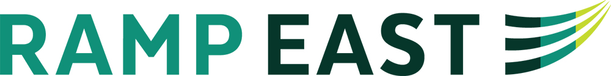

www.rampeast.com
What Employers are Saying about needed skills….
- Excel-formulas and pivot tables
- technical writing
- collaboration
- basic etiquette
- social media savvy
- resume wording
- NCWorks knowledge
- featuring
  - introductory video
  - participating employers by county
  - community college class offering (AMI)
  - contact information

Recruiter positions
- filling immediate needs
- accessing the talent pipeline
PLEASE LET YOUR RECRUITERS KNOW:
- If job seekers have any issues with the website.
- If your center is planning (or knows of) a recruiting event or job fair.
- If your staff needs more information on RAMP East.
- If your staff would like to assist with job seeker prep during AMI classes at the local community college.
Angie Jenkins, Turning Point
252-287-8991
ajenkins@rampeast.org

Christy Harris, Region Q
252-809-2516
charris@rampeast.org

- Regional and county job fairs
- high school recruitment/visits
- field trips to businesses (Fall/Spring)
- externships for teachers
- apprenticeships

