Welcome to Wilson Community College Dr. Tim Wright, President
Welcome and Introductions Walter Dorsey, Chair
Review of 2018/2019 projects Brandi Bragg, Facilitator
Plans for 2019/2020 projects

Local Implementation Certifications Larry Donley, NCWorks Regional
-Halifax Community College Area Operations Director- NEPZ
-Edgecombe Community College Area

NETWORKING BREAK

Our Pathways: Industry Perspective

-Health Care Lisa Lassiter, Administrator of Careers
Vidant Health
-Advanced Manufacturing Charles Gilmore, Training Supervisor
Sara Lee Frozen Bakery
-Business Support Services Crystal Lyons, HR Manager
Reser’s Fine Foods

NC Simulation Station Robert Hiett, Executive Director
Upper Coastal Plain Council of Government
Michael Williams, Director
Turning Point WDB

Adjourn Walter Dorsey

Please stay for a demonstration of NC Simulation Station.

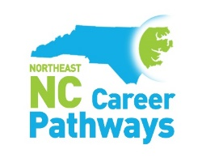
www.nencpathways.org

