**Explanation by the Numbers:**

**WHY ARE THERE SO MANY RED NUMBERS?**

In short, let’s look at what is going on in manufacturing and Health Care…

Because historical data is taken into account to generate projections (5, 10, 15 year spans) industries that have historically lost jobs because of cyclical probabilities will likely have bleaker projection estimates compared to high-growth industry sectors. Even if growth has occurred recently (last five years) job losses over 10 or 15 year periods has dampen projected growth of the historic legacy industry sectors. And if you notice all the red numbers reported in the job projections that is exactly what is going on in Manufacturing. Job losses were so heavy during the Great Recession that the projection data is still being heavily influenced by those massive layoffs. You need to remember that anytime a downturn in the economy occurs there is a trickle-down effect on not just the major manufacturing companies but also on the entire supply chain, companies that supply key components to the major manufacturers affect future employment numbers.

This is a National issue not just unique to the Northeastern Prosperity Zone. The graph below will help to illustrate how all three regions, regardless of current growth in manufacturing, were trending downward post -2019.

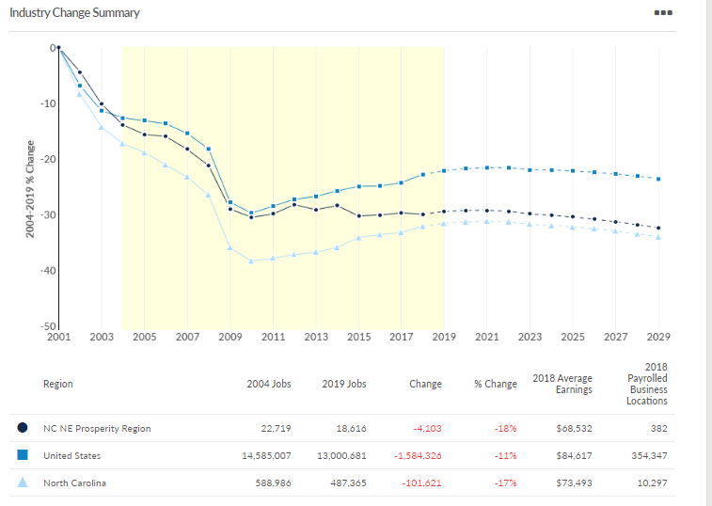

**All hope is not lost for manufacturing!**

To get the full picture for Manufacturing digging a little deeper beyond the broad sector will help us better understand what’s going on. The table below illustrates where the job losses in manufacturing have occurred form 2004-2019 in the Northeastern Economic Prosperity Zone.

|  |  |  |  |  |  |
| --- | --- | --- | --- | --- | --- |
| NAICS | Description | 2004 Jobs | 2019 Jobs | 2004 - 2019 Change | 2004 - 2019 % Change |
| 339994 | Broom, Brush, and Mop Manufacturing | 177 | 0 | (177) | (100%) |
| 311412 | Frozen Specialty Food Manufacturing | 197 | 0 | (197) | (100%) |
| 313310 | Textile and Fabric Finishing Mills | 492 | 293 | (199) | (40%) |
| 322121 | Paper (except Newsprint) Mills | 620 | 376 | (244) | (39%) |
| 336310 | Motor Vehicle Gasoline Engine and Engine Parts Manufacturing | 513 | 228 | (285) | (56%) |
| 332313 | Plate Work Manufacturing | 343 | 42 | (301) | (88%) |
| 321113 | Sawmills | 1,310 | 971 | (339) | (26%) |
| 336330 | Motor Vehicle Steering and Suspension Components (except Spring) Manufacturing | 344 | 0 | (344) | (100%) |
| 325312 | Phosphatic Fertilizer Manufacturing | 1,048 | 684 | (364) | (35%) |
| 336612 | Boat Building | 1,370 | 974 | (396) | (29%) |
| 313110 | Fiber, Yarn, and Thread Mills | 607 | 157 | (450) | (74%) |
| 322130 | Paperboard Mills | 598 | 128 | (470) | (79%) |
| 313240 | Knit Fabric Mills | 1,227 | 0 | (1,227) | (100%) |

It seems to be more traditional or legacy industries that have suffered tremendously in the Great Recession not only in our region but across the country. Some of these sectors no longer have employment! For instance, look at a list of manufacturers in your area and notice the businesses that may have been leading employers who are no longer in business. So to emphasize why the current numbers do not reflect future opportunity in our legacy industries and what we are seeing now is due to the massive job losses reflected in the manufacturing data, and play an important role in our most recent occupational projections, as reflected by all the **RED** numbers.

***There is good news*** as you will hear shortly from Lisa Lassiter from Vidant Health in the growing health care sector. However, before I turn it over to her, I would like to show you a deeper look that illustrates what is on the horizon for the Manufacturing Sector and more specifically the *Advanced Manufacturing Sector*.

|  |  |  |  |  |  |
| --- | --- | --- | --- | --- | --- |
| NAICS | Description | 2004 Jobs | 2019 Jobs | 2004 - 2019 Change | 2004 - 2019 % Change |
| 325412 | Pharmaceutical Preparation Manufacturing | 916 | 1,931 | 1,015 | 111% |
| 311911 | Roasted Nuts and Peanut Butter Manufacturing | 190 | 706 | 516 | 272% |
| 322110 | Pulp Mills | 52 | 456 | 404 | 777% |
| 334513 | Instruments and Related Products Manufacturing for Measuring, Displaying, and Controlling Industrial Process Variables | 0 | 403 | 403 | Insf. Data |
| 336390 | Other Motor Vehicle Parts Manufacturing | 294 | 623 | 329 | 112% |
| 311999 | All Other Miscellaneous Food Manufacturing | 99 | 375 | 276 | 279% |
| 325320 | Pesticide and Other Agricultural Chemical Manufacturing | 48 | 277 | 229 | 477% |
| 331110 | Iron and Steel Mills and Ferroalloy Manufacturing | 398 | 538 | 140 | 35% |
| 325220 | Artificial and Synthetic Fibers and Filaments Manufacturing | 19 | 145 | 126 | 663% |
| 321213 | Engineered Wood Member (except Truss) Manufacturing | 14 | 136 | 122 | 871% |
| 335312 | Motor and Generator Manufacturing | 33 | 153 | 120 | 364% |

Conversely, the Advanced Manufacturing Sector has experienced quite a bit of growth over the projected reference period. Perhaps unsurprisingly, they are generally jobs that are *utilizing high levels of technology* *and materials*, with requirements that the workforce possess higher levels of skills to succeed in this High-Growth Industry Sector. These modern and emerging technologies include many brand-new forms of automation that did not exist before the Great Recession and have recently become more prominent with larger upscale industries. This also sets the emergent and existing workforce up for learning new skills associated with maintaining these high-end technology-driven businesses. It will require a more in-depth look at the training and collaboration with employers to ensure that our partners are delivering what employers expect. The former ways used to develop curriculum may change based on employer needs. Core competencies may stay the same, but the technical skills will require more concentrated job-specific skills training than we have seen in many years. It is very likely some employers have not identified the new technology driving their industries and will depend on our training system to help navigate options to plan for the future. This will require greater collaboration between partner agencies to address employer needs.

The Convergence from old manufacturing or legacy industry sectors to new higher technology-driven manufacturing or advanced manufacturing is upon us now, and waiting to catch up is not an option. There are conversations that need to happen now to plan and fund the training for these emergent occupations, and quick concept t00raining will not satisfy employer needs. However, aligning foundational skills found on the job with the K-12 systems core curriculum will help transition workers into high-growth industry sectors with greater success, and employer satisfaction. The emergent occupations will require a greater competency in workplace documents, graphic literacy, and applied mathematics. These foundational skills will be used as qualifiers for entry into a job. Furthermore, a greater collaboration with employers will reveal where our systems should focus to provide a more concentrated job-specific skills training to ensure job seekers keep a job. There as several ways to accomplish this and one is to continue the perpetuation of the National Career Readiness Certifications from the K-12 Education System, and promote job profiling to determine the needed skills sets while in the job. It is a proven fact that those who demonstrate adequate foundational skills competencies are more likely to stay in a job and be promoted while on the job.

The challenge for our region is to be ready for the projected job growth coming to the Northeastern Prosperity Zone. How we prepare for this now will determine the success of the region. There are over five-thousand new jobs in advanced manufacturing alone projected in the next 2-5 years, with over half of those jobs expected to arrive in 2020. This does not include other high-growth industry sectors that are growing rapidly like Health Care, and Business Supportive Services.

**Now for the better news from Lisa.**