- Log into Tratiify as an administrator. Hover over your name at the top right, then click “Resources.”
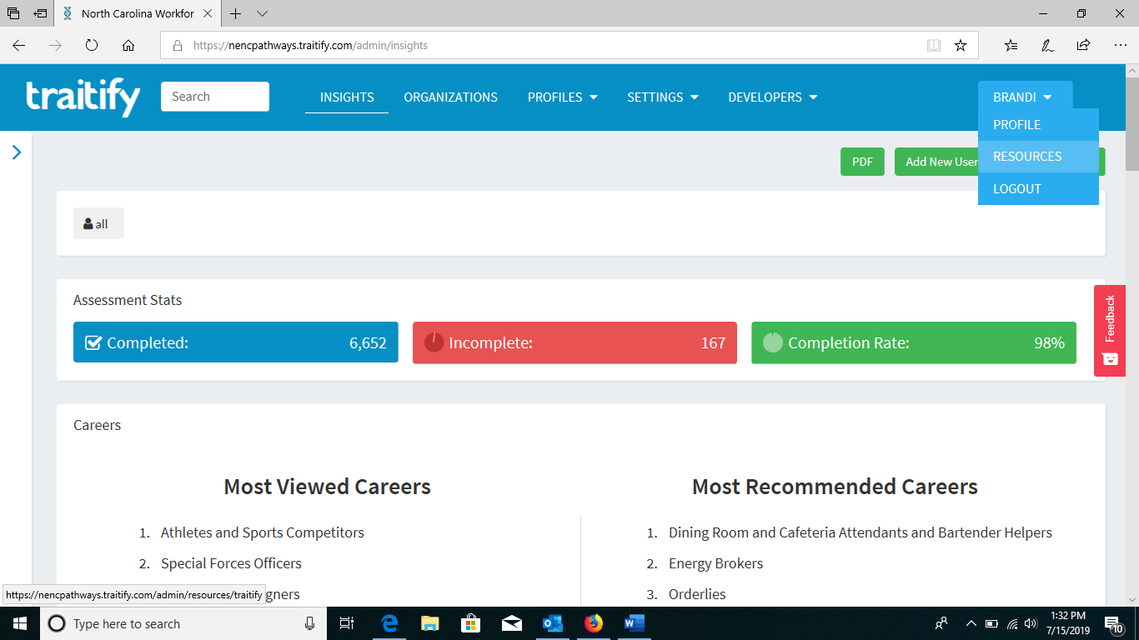

- Choose “Handouts” from the menu.

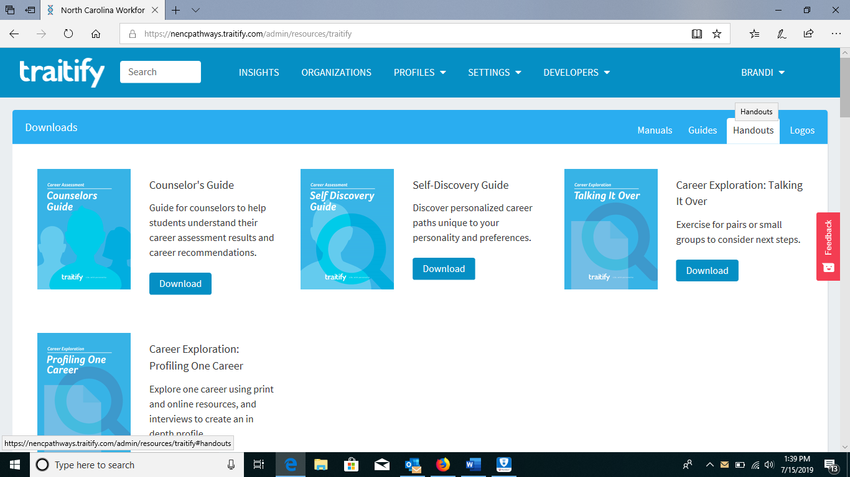

- Download “Self-Discovery Guide”

